# MOTION BASED MESSAGE CONVEYOR FOR

# PHYSICALLY DISABLED PEOPLE

**A Mini Project Report Submitted in Partial Fulfilment of the Requirement for the Award of the Degree of**

**BACHELOR OF TECHNOLOGY**

in

## ELECTRONICS AND COMMUNICATION ENGINEERING

**by**

**DOGGA THARUN KUMAR 19PA1A0440**

**GUNUPUDI RAJ PRAKASH 19PA1A0456**

**BOJJA GANESH 20PA5A0403**

**CHAGANTI MANJUNATH REDDY 19PA1A0422**

**GOLLA JOSHUA 19PA1A0448**

Under the Esteemed Guidance of

### Mrs. D. MANASWI

### Assistant Professor



**DEPARTMENT OF ELECTRONICS AND COMMUNICATION ENGINEERING VISHNU INSTITUTE OF TECHNOLOGY (Autonomous)**

**(Accredited by NBA, NAAC, Approved by AICTE & Affiliated to JNTU Kakinada) Vishnupur, Bhimavaram - 534202.**

**2020 - 2021**

**VISHNU INSTITUTE OF TECHNOLOGY (AUTONOMOUS)**

## (Accredited by NBA, NAAC, Approved by AICTE & Affiliated to JNTU Kakinada) Vishnupur, Bhimavaram-534202

**DEPARTMENT OF ELECTRONICS AND COMMUNATION ENGINEERING**



## CERTIFICATE

This is to certify that the Mini Project entitled **“Motion Based Message Conveyor for Physically Disabled People”** is being submitted by **DOGGA THARUN KUMAR (19PA1A0440**), **GUNUPUDI RAJ PRAKASH (19PA1A0456), BOJJA GANESH**

### (20PA5A0403), CHAGANTI MANJUNATH REDDY (19PA1A0422),

**GOLLA JOSHUA (19PA1A0448)** in partial fulfilment for the award of the degree of **Bachelor of Technology in Electronics and Communication Engineering** is a record of the bonafide work carried out by them under my guidance and supervision during academic year 2020–2021 and it has been found worthy of acceptance according to the requirements of the university.

|  |  |
| --- | --- |
| **Mrs. D. Manaswi, Assistant Professor** | **Dr. N. Padmavathy,** Ph. D (IIT- KGP) |
| **Project Guide** | **Professor & Head** |

**External Examiner**

# ABSTRACT

We come across hospitals and NGO’s serving disabled people. Now these people are not capable of full body movement as compared to a normal person. In such a situation we propose a system that helps disabled person display a message by just simple motion of any part of his body. Our proposed system works by reading the tilt direction of the user part. This device needs to be mounted on user finger of hand. The user now just needs to tilt the device in a particular angle to convey a message. Tilting the device in different directions conveys a different message. Here we use accelerometer in order to measure the statistics of motion. It then passes on this data to the microcontroller. The microcontroller processes the data and displays the particular message as per input obtained. The microcontroller now displays the associated message on the LCD screen. It also sounds a buzzer along with message as soon as it receives motion signal from the accelerometer. The patient motion recorder device consists of an RF transmitter in order to transfer the data signal. An RF receiver on the other side receives the data and then decodes it before passing it to the microcontroller for processing the input and responding to it.

**KEYWORDS:**

Physically Disabled, Paralytic Patients, Accelometer – Motion, Microcontroller, Communication, Buzzer, LCD Display.

# CONTENTS

**Topic Page No**

**Abstract iii**

1. **INTRODUCTION 1 - 3**

1.1 Physically Disabled Patients

1. **METHODOLOGY 4 - 7**

2.1 Hardware Description

* 1. System Working

**3. RESULTS AND DISCUSSION 8 - 12**

3.1 Results

3.2 Discussions

3.3 Future Scope

* 1. Acknowledgement

1. **CONCLUSION 13 - 14**
2. **REFERENCES 15**
3. **APPENDIX 16**

**CHAPTER I**

# INTRODUCTION

1

## 1. INTRODUCTION

Among the large number of advancements done in the medical sector, very few actually focus on helping patients with disabilities to communicate. Although monitoring systems make it easier for doctors to collect and observe a patient’s vitals, there aren’t many options for actual verbal communication for disabled patients. Here we propose a simple yet effective way to solve this age-old problem. The main purpose is to replace the conventional approach of patient-nurse communication with modern technologies that provide a much faster and reliable way. In the current scenario, the patient has to be dependent on a family member or mostly a nurse both of which have to attend the patient constantly. Our objective is to make such patients independent to communicate with the nurse by the simple task of tilting a device located on his finger or any other part of the body that is capable of movement. This will not only help the patient but also ease out the nurse’s job. As a single nurse is responsible for a number of patients, the time required for each nurse to visit every patient to meet his needs will be saved. After the patient sends the message the nurse can remotely monitor their requests and provide assistance without any further delay. A buzzer is placed and it will alert the nurse in case of an emergency. To make the system more dynamic all these ideas together thus focus on building a smart system to make patients self-sufficient, and assist the nurses, doctors and family members at the same time.

### 1.1 PHYSICALLY DISABLED PATIENTS

A physical disability is a substantial and long-term condition affecting a part of a person’s body that impairs and limits their physical functioning, mobility, stamina or dexterity. The loss of physical capacity results in the person having a reduced ability, or inability, to perform body movements such as walking, moving their hands and arms, sitting and standing as well as controlling their muscles. A physical disability does not necessarily stop you from performing specific tasks but makes them more challenging. This includes daily tasks taking longer to complete, such as getting dressed or difficulty gripping and carrying things. A person may be born with a physical disability or acquire it in life due to an accident, injury, illness or as a side effect of a medical condition.

**It is important to note that defining physical disability is not about the physical condition itself but how it impacts daily life, such as the ability to carry out work activities.**

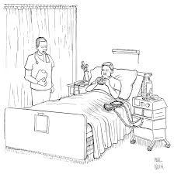

## Chapter 2

**METHODOLOGY**

### 2. METHODOLOGY

**2.1 HARDWARE DESCRIPTION**

Firstly, let us know about main Hardware Specifications:

**2.1.1 Arduino Nano Board**

Arduino Nano is a small complete chip board based on ATmega 328 (v3.0) or Atmega 168 (v2.0). Every Arduino has the same functionality and the same features except the number of pins and size. One of the major flaws of this board is that it doesn't have any power jack. So, you can't supply power from any external power source like a battery. Apart from this, more or less this board is quite similar to any Arduino board.

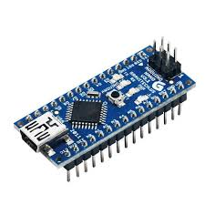

**2.1.2 LCD 16*2 Display**

LCD (Liquid Crystal Display) screen is an electronic display module and find a wide range of applications. A 16x2 LCD display is very basic module and is very commonly used in various devices and circuits. These Modules are preferred over seven segments and other multi segment LEDs. The reasons being: LCDs are economical; easily programmable; have no limitation of displaying special & even custom characters (unlike in seven segments), animations.

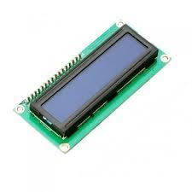

**2.1.3 Accelerometer**

The Accelometer is a small, thin, low power, complete 3-axis accelerometer with signal conditioned voltage outputs. The product measures acceleration with a minimum full-scale range of ±3 g. It can measure the static acceleration of gravity in tilt-sensing applications, as well as dynamic acceleration resulting from motion, shock, or vibration. The user selects the bandwidth of the accelerometer using the CX, CY, and CZ capacitors at the XOUT, YOUT, and ZOUT pins.

Bandwidths can be selected to suit the application, with a range of 0.5 Hz to 1600 Hz for the X and Y axes, and a range of 0.5 Hz to 550 Hz for the Z axis. The ADXL335 is available in a small, low profile, 4 mm x 4 mm x 1.45 mm, 16-lead, plastic lead frame chip scale package.

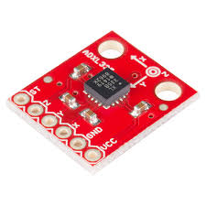

**2.2 SYSTEM WORKING**

Accelerometer is connected to Arduino Uno controller which will acts as an input. The heart of our system is accelerometer. This can be two axis or three axis static accelerometer connected to analog input of controller. It is interface with controller to sense the acceleration. The controller is the second stage of system. The controller processes the data from the accelerometer and if the conditions are satisfied it selects the message which is set and it is further given to LCD. The instruction will be displayed on LCD. At the same time that instruction will be given to speech module and speaker. So that patient will be able to hear whether the given instruction is correct or not. We can insert the SD Card/ memory card in that we can store the instructions or messages which is to be given by the patient. At the same time buzzer will turn on and it gives alert to the doctors and nurse or relatives of patient.

**2.2.1 BLOCK DIAGRAM**

According to the proposed methodology, the following block diagrams were proposed to meet the requirements of the system. The heart of the transmitter unit is the accelerometer. This can be a two axis or a three-axis static accelerometer connected to the analog inputs of the controller. It is interfaced with the controller to sense the acceleration. The controller is the second stage of the transmitter. The controller processes the data from the accelerometer and if the conditions are satisfied it sends the data to the next stage that is the LCD Display.

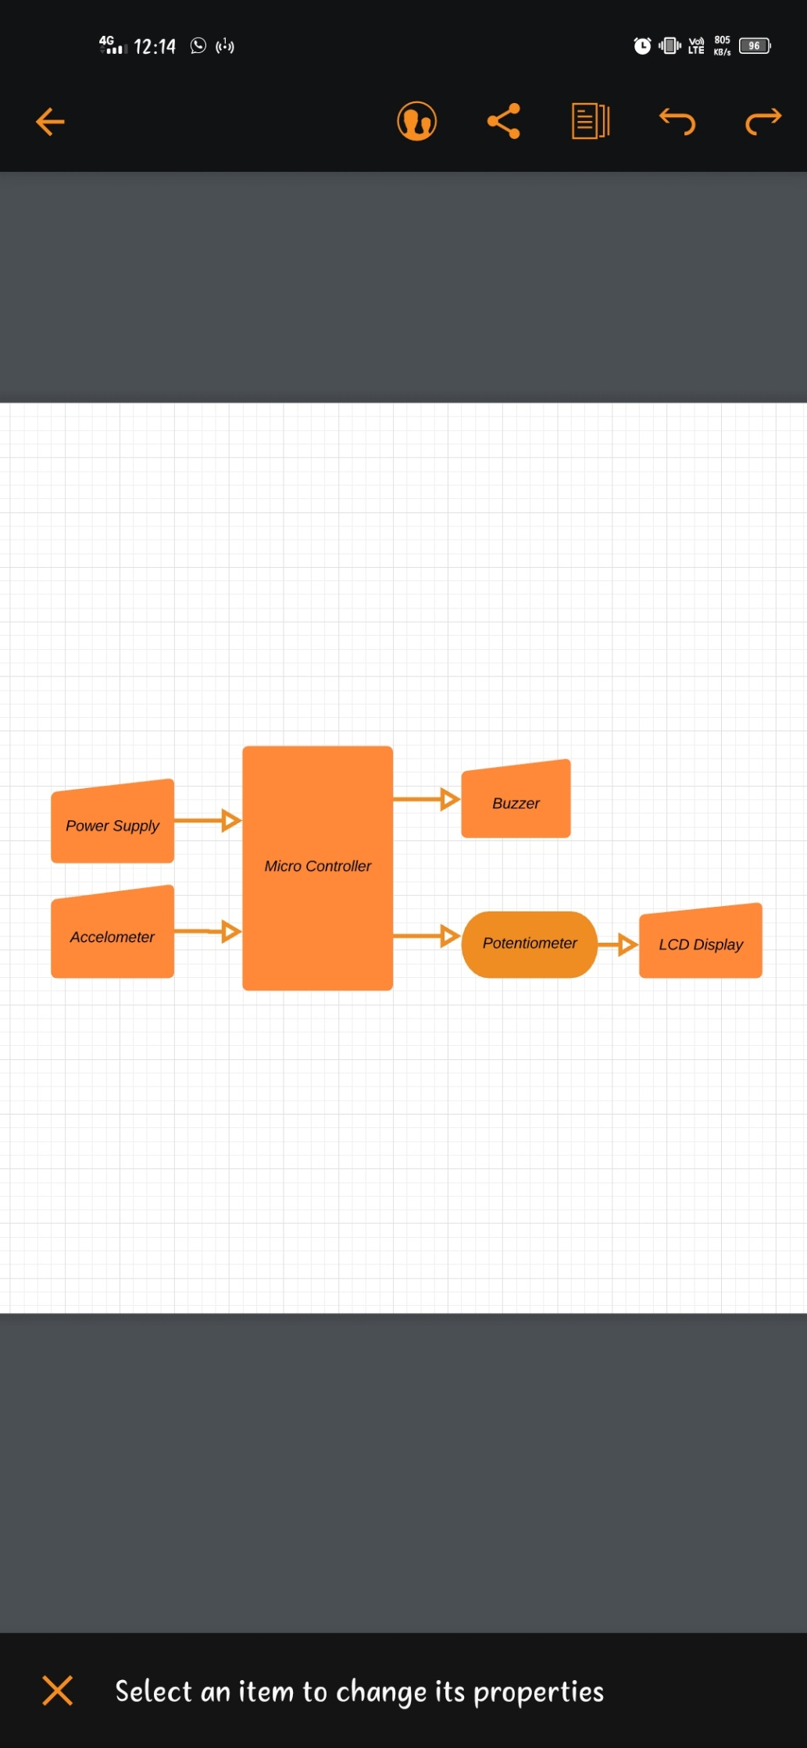

**2.2.2 FLOW CHART**

As shown in above flowchart, the process will be as follows Device will be started first by giving power supply to it. All the sensors i.e., Accelerometer, temperature sensor will be on. To work the device there needs to be the motion of the accelerometer in some of the angle in any direction. There will be programmed instructions for every movement of the accelerometer i.e., for each direction. If there is motion of the device in any direction then there will be an alarm and a programmed message will be sent to the receiver which will be displayed on the LCD display connected to the receiver. If the device is steady i.e., there is no any device motion then there will be no alarm and message. So, process will end.

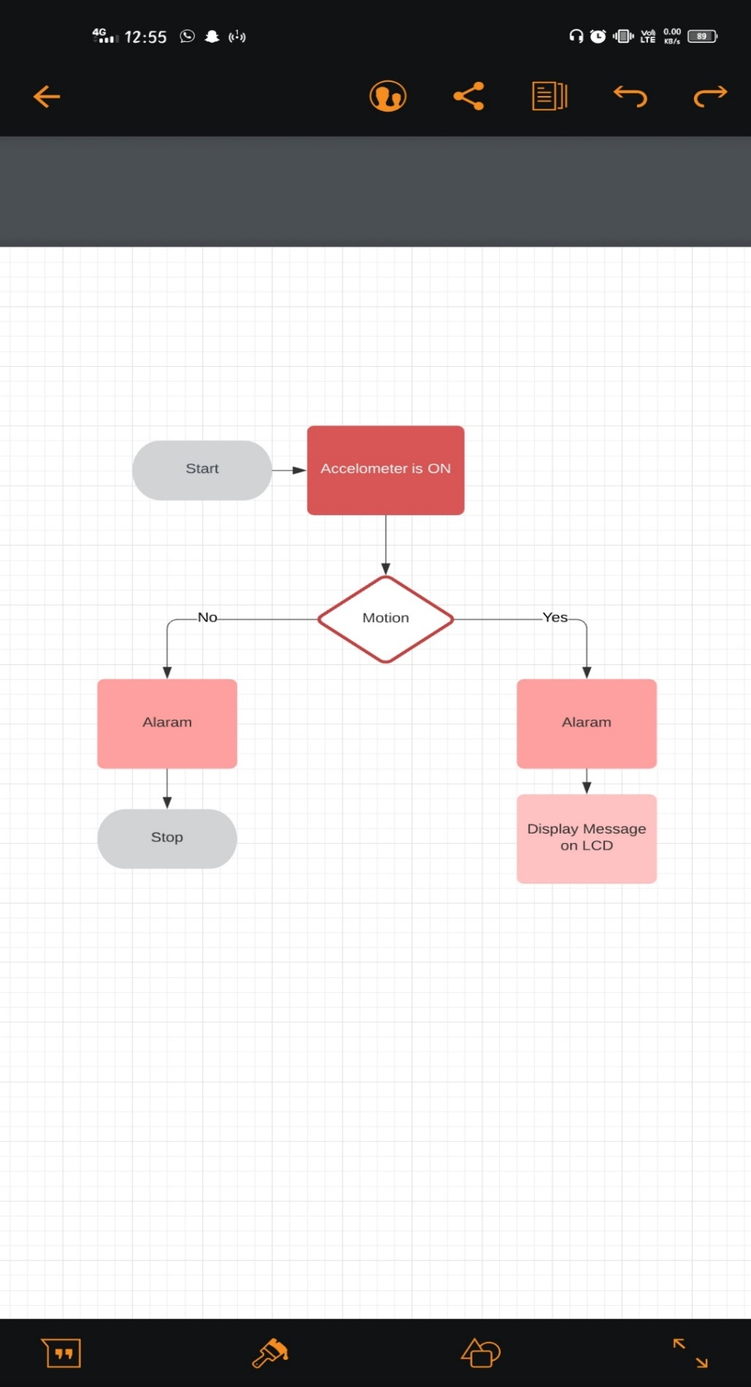

## CHAPTER 3

**RESULTS AND DISCUSSION**

### 3. RESULTS AND DISCUSSION

#### The system is fully automated, reliable, and convenient. The simulation of the system is done in the Arduino software. Our project shows the successful transmission of three different messages. One of the most effective function of the system is the message given by the patient is able to hear through speakers. As well as the message is remotely sent to doctor of concerned person through SMS. When accelerometer is titled to right side then the message displayed is “PAIN”, when the accelerometer is tilted to left side then the message displayed is “HUNGRY” and when the accelerometer is tilted in upward direction the message displayed is “EMERGENCY”.

#### 3.1 RESULTS

As we used a three-axis accelometer, it the detects the motion of three angles. Here we can see the results of the project:

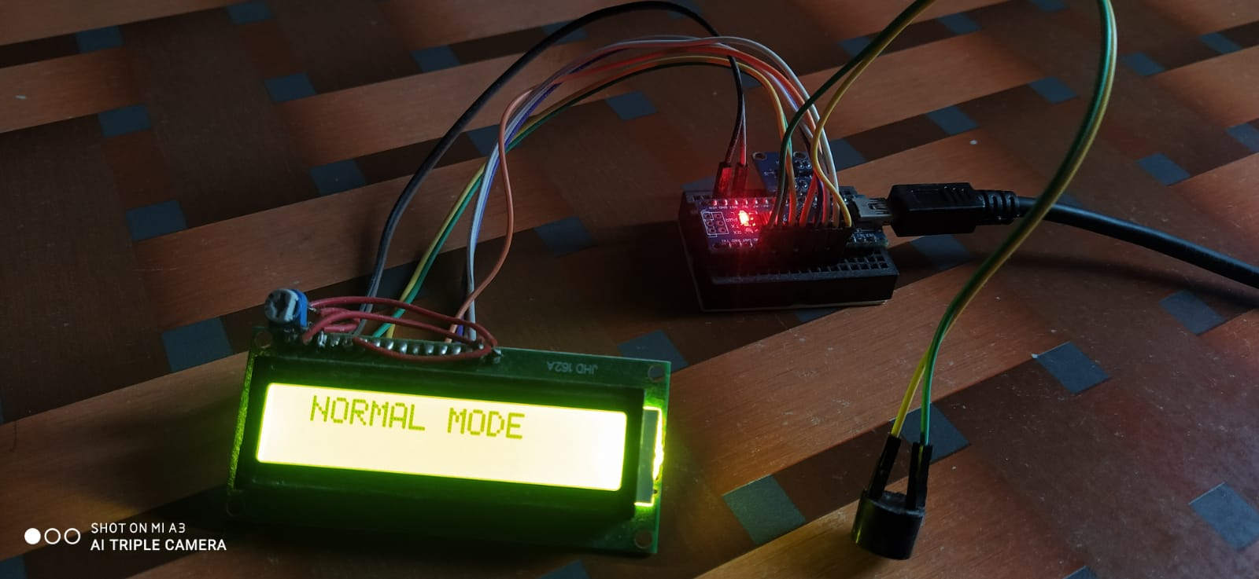

**Fig(a). Message when at rest**

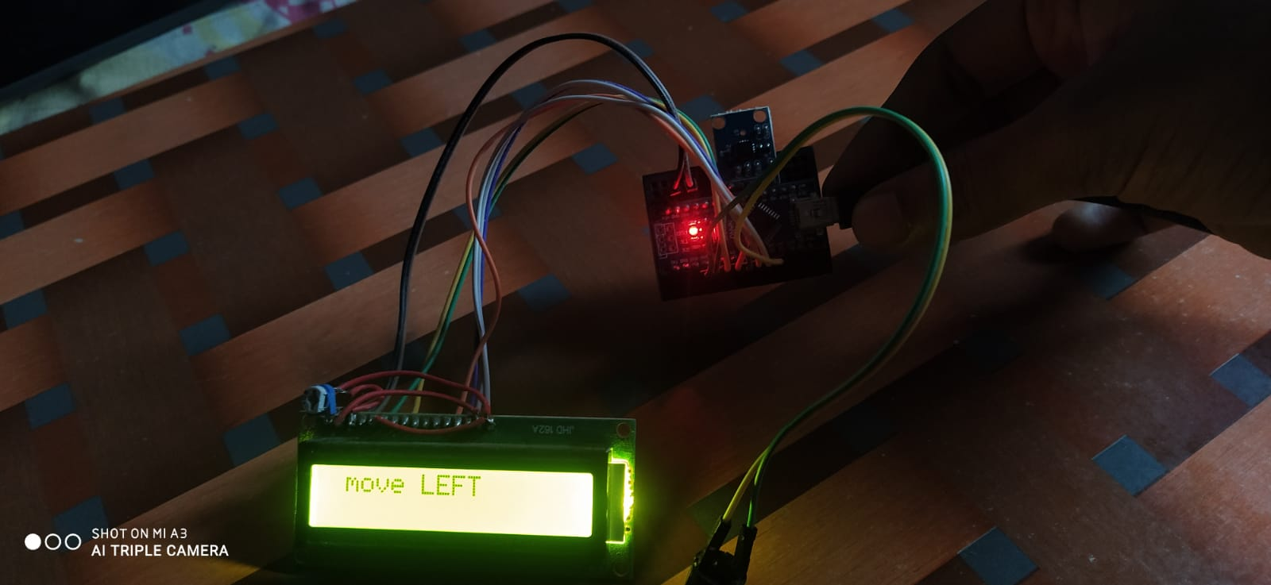

**Fig(b). Message when tilted in left direction**

#### 

**Fig(c). Message when tilted in right direction**

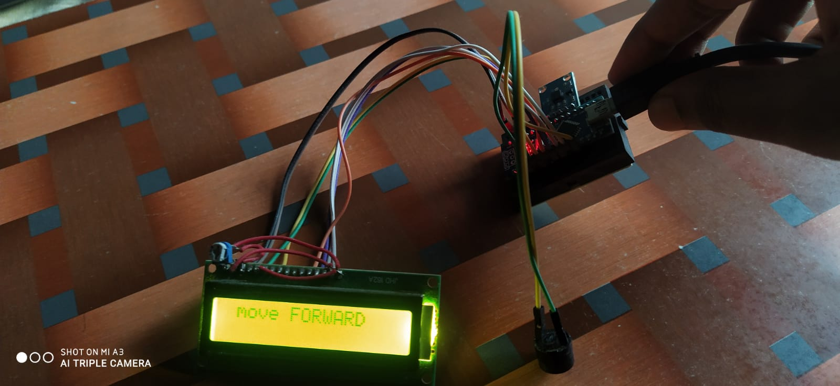

**Fig(d). Message when tilted in upward direction**

#### 3.2 DISCUSSIONS

By implementing this system, a simple device for paralyzed or disabled person achieved without use of complex form of inputs. Communication through this system is very fast and effective. Excellent approach implemented between patient–nurse communication.

**3.3 FUTURE SCOPE**

We can also use the Android Application, by which the real time patient’s health status updates will be given to the doctor. Then the doctor will give immediate solutions to the nurse or on the status of the patient’s health. We can use the Wi-Fi system for communication. By using Wi-Fi system, we can expand the communication distance. We can transmit and receive message through the long distance.

**3.4 ACKNOWLEDGEMENT**

We would like to acknowledge and extend our heartfelt gratitude to all those people who have been associated with this project and have helped us with it thus making it a worthwhile experience.

Firstly, we extend our thanks to various people which include our project Guide Mrs. D. Manaswi who has shared their opinions and experiences through which we received the required information crucial for our project. We are also thankful to Head of Department Dr. Padmavathi, project Co-Ordinator Dr. A. Prabhakar Rao and all the staff members of Electronics and communication Department for their highly co-operative and encouraging attitudes, which have always boosted us.

**CHAPTER 4**

**CONCLUSION**

### 4. CONCLUSION

This device has made conveyance of message possible only by the motion of a body part. The ease of message conveyance is the main advantage of this system along with the real time user defined medicine alarm. By implementing this system, a simple device for paralyzed or disabled people can be achieved without the use of complex form of inputs. The prototype we have made is fully functional but restricted to a small area of operation. For a large area and transmission distance the type of communication used have to be more effective and faster. Our system successfully proves that this system is an excellent approach to be implemented at hospitals for patient-nurse communication. The project can be further developed into an automatic wheel chair wherein the wheelchair will be moved just by hand gesture. Also, along with only message transmission other data like body temperature, pulse rate etc. can also be transmitted to the nurse so that a real time record of all the patients is maintained.

**REFERENCES**

[1] RuizeXu, Shengli Zhou, and Wen J. Li, Fellow, IEEE, “MEMS Accelerometer Based Nonspecific-User Hand Gesture Recognition”, IEEE SENSORS JOURNAL, VOL. 12, NO. 5, MAY 2012.

[2] Prof. Vishal V. Pande, Nikita S. Ubale et.al “Hand Gesture Based Wheelchair Movement Control for Disabled Person Using MEMS.”, IJERA, Vol. 4, Issue 4, April 2014.

[3] SakshiGoyal, Ishita Sharma, Shanu Sharma, “Sign Language Recognition System for Deaf and Dumb People”, IJERT, Vol. 2 Issue 4, April – 2013.

[4] Amarjot Singh, Devinder Kumar et.al “An Intelligent Multi-Gesture Spotting Robot to Assist Persons with Disabilities”.

[5] ShreedeepGangopadhyay, Somsubhra Mukherjee, Soumya Chatterjee, “Intelligent gesture controlled wireless wheelchair for the physically handicapped”, Proceedings of Fifth IRAJ International Conference, 15th September 2013, Pune, India.

**APPENDIX**

<https://github.com/19pa1a0440/miniproject>